### 

### Semester One Examination, 2022

### Question/Answer booklet

# MATHEMATICS SPECIALIST

**UNIT 3**

## Section One:

## Calculator-free

|  |
| --- |
|  |

Your Name

Your Teacher’s Name

## Time allowed for this section

Reading time before commencing work: five minutes

Working time: fifty minutes

## Materials required/recommended for this section

***To be provided by the supervisor***

This Question/Answer booklet

Formula sheet

***To be provided by the candidate***

Standard items: pens (blue/black preferred), pencils (including coloured), sharpener, correction fluid/tape, eraser, ruler, highlighters

Special items: nil

## Important note to candidates

No other items may be taken into the examination room. It is **your** responsibility to ensure that you do not have any unauthorised material. If you have any unauthorised material with you, hand it to the supervisor **before** reading any further.

|  |  |  |  |  |  |
| --- | --- | --- | --- | --- | --- |
| Question | Mark | Max | Question | Mark | Max |
| 1 |  |  | 5 |  |  |
| 2 |  |  | 6 |  |  |
| 3 |  |  | 7 |  |  |
| 4 |  |  | 8 |  |  |

**Structure of this paper**

|  |  |  |  |  |  |
| --- | --- | --- | --- | --- | --- |
| Section | Number of questions available | Number of questions to be answered | Working time (minutes) | Marks available | Percentage of examination |
| Section One:  Calculator-free | 8 | 8 | 50 | 52 | 35 |
| Section Two:  Calculator-assumed | 14 | 14 | 100 | 97 | 65 |
|  |  |  |  | **Total** | 100 |

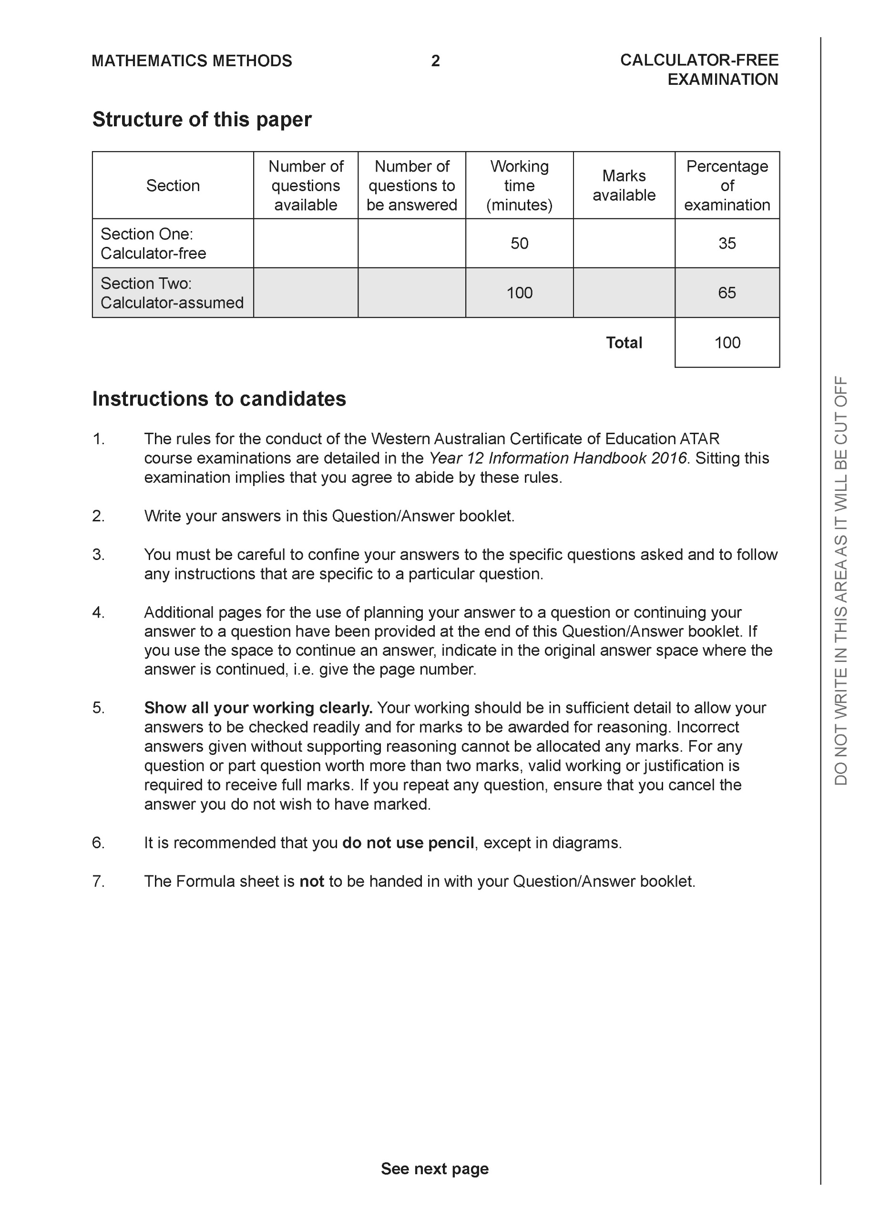

**Section One: Calculator-free (52 Marks)**

This section has **eight (8)** questions. Answer **all** questions. Write your answers in the spaces provided.

Spare pages are included at the end of this booklet. They can be used for planning your responses and/or as additional space if required to continue an answer.

● Planning: If you use the spare pages for planning, indicate this clearly at the top of the page.

● Continuing an answer: If you need to use the space to continue an answer, indicate in the original answer space where the answer is continued, i.e. give the page number. Fill in the number of the question that you are continuing to answer at the top of the page.

Working time: 50 minutes.

**Question 1 (4 marks)**

Consider the complex number  as plotted on the complex plane below.

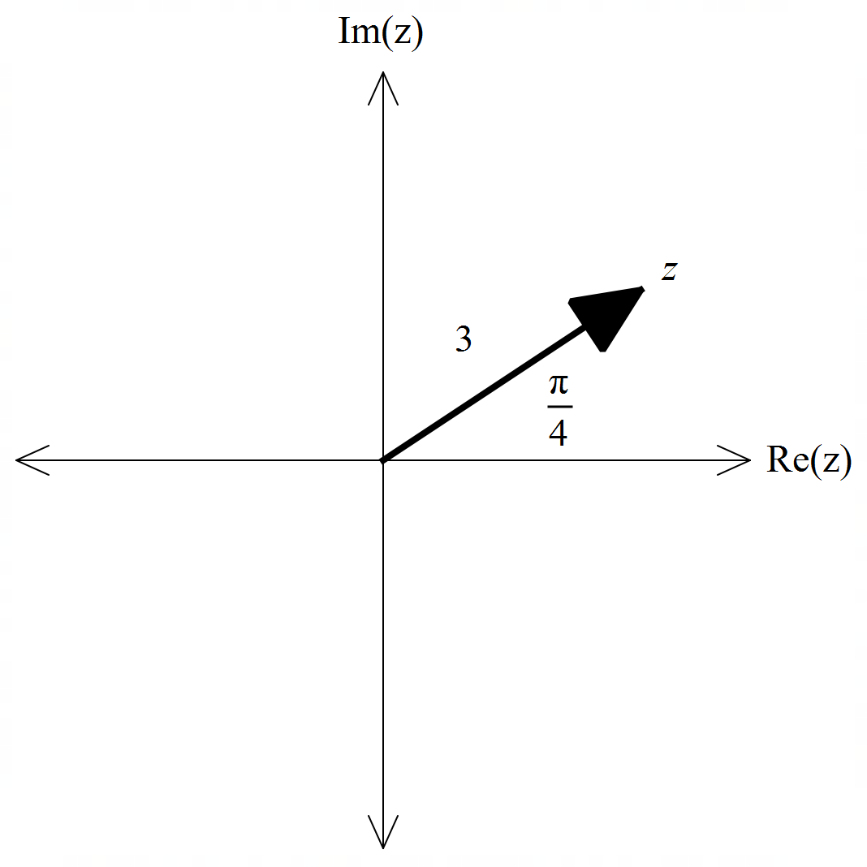

1. Determine the exact value of  and plot on the axes above. (2 marks)
2. Determine the exact value of. (2 marks)

**Question 2 (8 marks)**

Consider the functions  with domains shown in the graphs below.

|  |  |
| --- | --- |
| 1. Sketch the inverse functions above.   If they exist. (2 marks) |  |

1. Which of the following exist over natural domains,  ,  ? Explain.

State the natural domain and corresponding ranges for those that exist. (3 marks)

1. The rule for  is . State the inverse rule  and its domain. (3 marks)

**Question 3 (5 marks)**

Consider the function .

Plot on the axes below labelling intercepts and asymptotes.

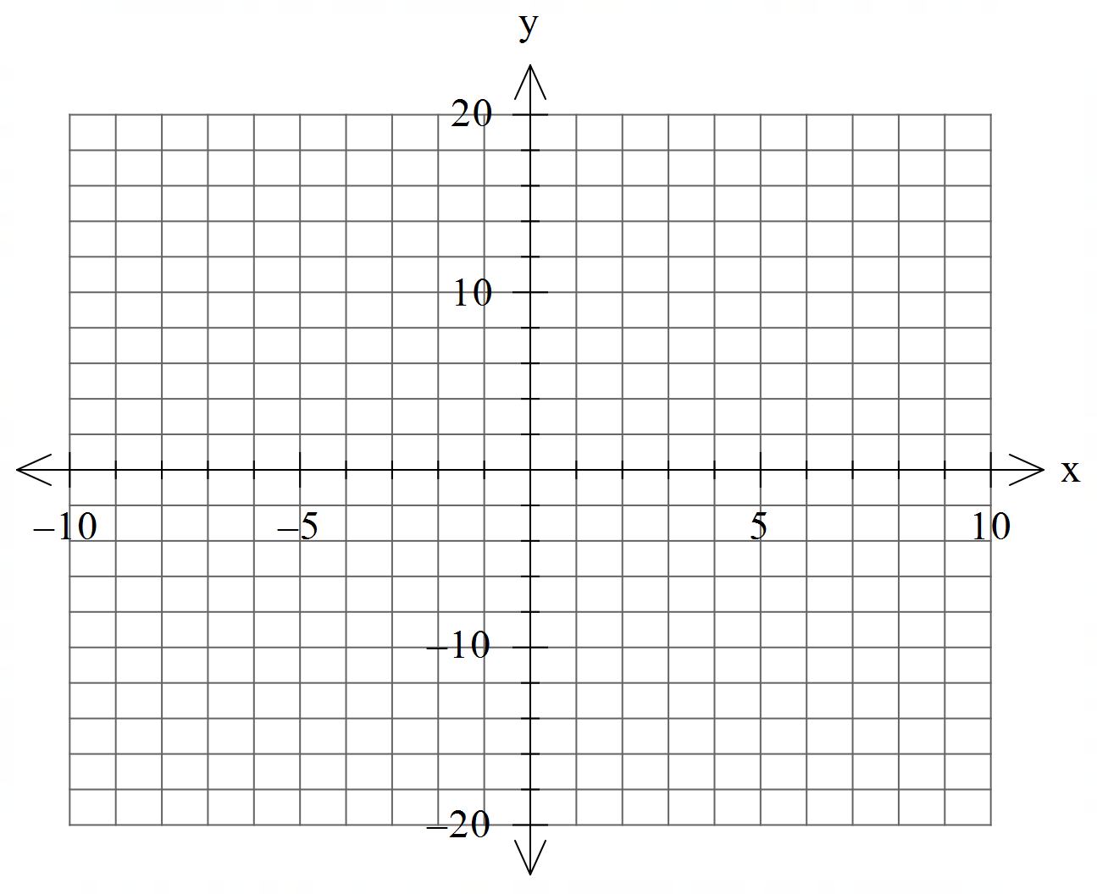

**Question 4 (8 marks)**

Consider the polynomial  for the complex variable .

1. Given that , determine a quadratic factor of . (3 marks)
2. If , determine all solutions to . (2 marks)
3.  can be expressed as  where  are real integers. Determine the values of . (3 marks)

**Question 5 (7 marks)**

Consider the function .

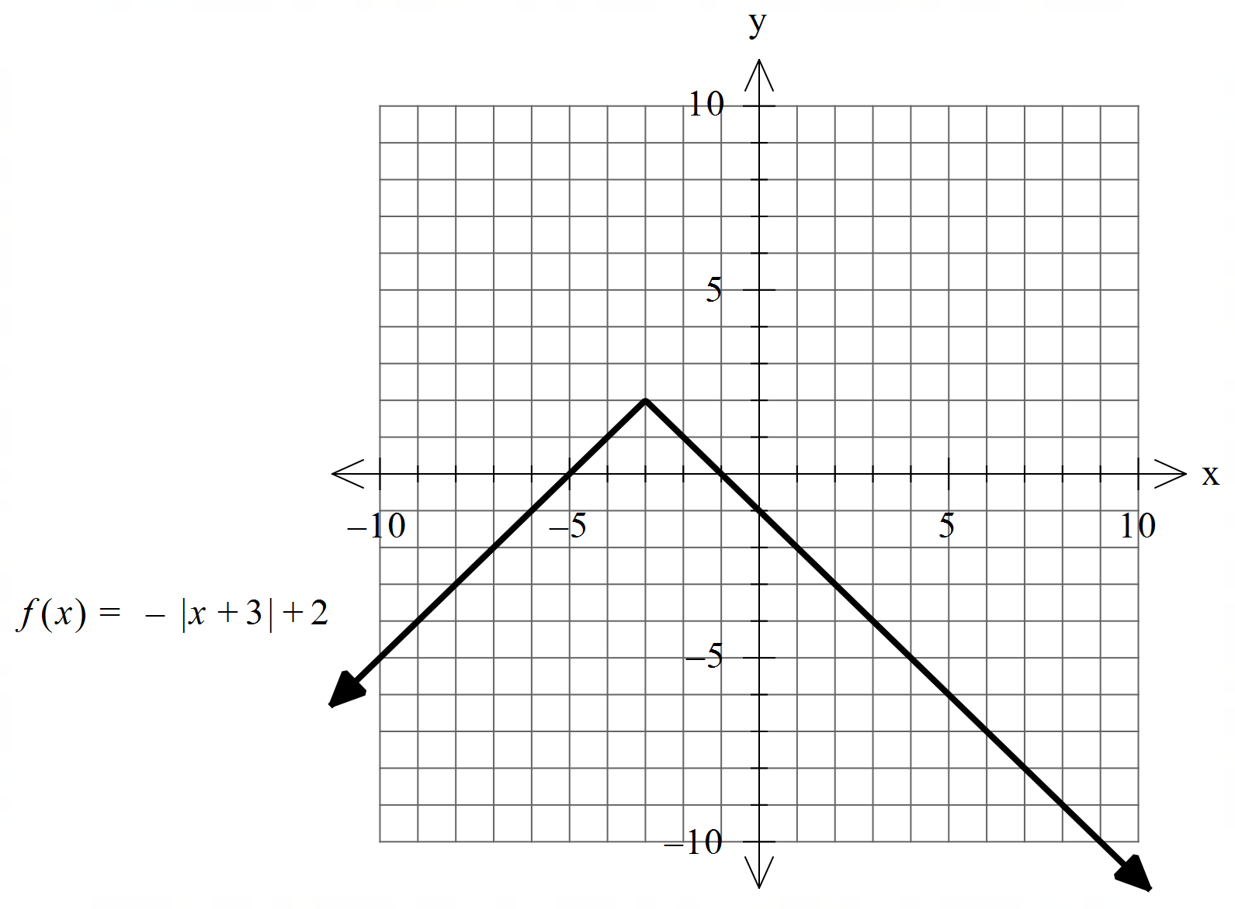

1. Sketch  on the axes below, labeling important features. (4 marks)

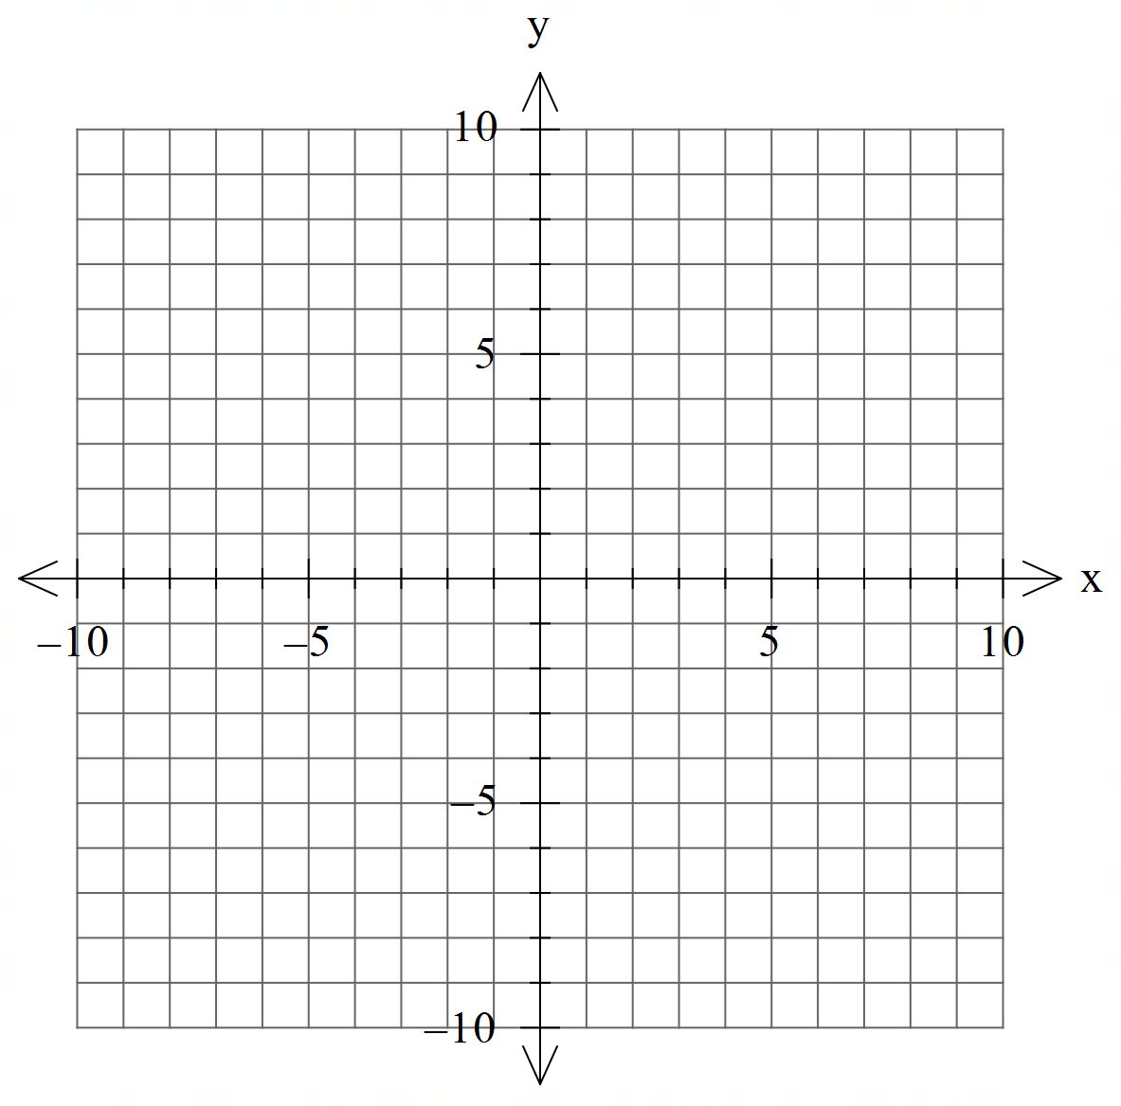

1. Hence determine the natural domain and range of  (3 marks)

**Question 6 (6 marks)**

Consider the linear equations 

1. Solve for . (3 marks)
2. Consider the following system where  are constants. (3 marks)

Solve for all possible values of for the following scenarios:

1. Unique solution
2. Infinite solutions
3. No solutions.

**Question 7 (10 marks)**

Consider the function  for  which is plotted below.

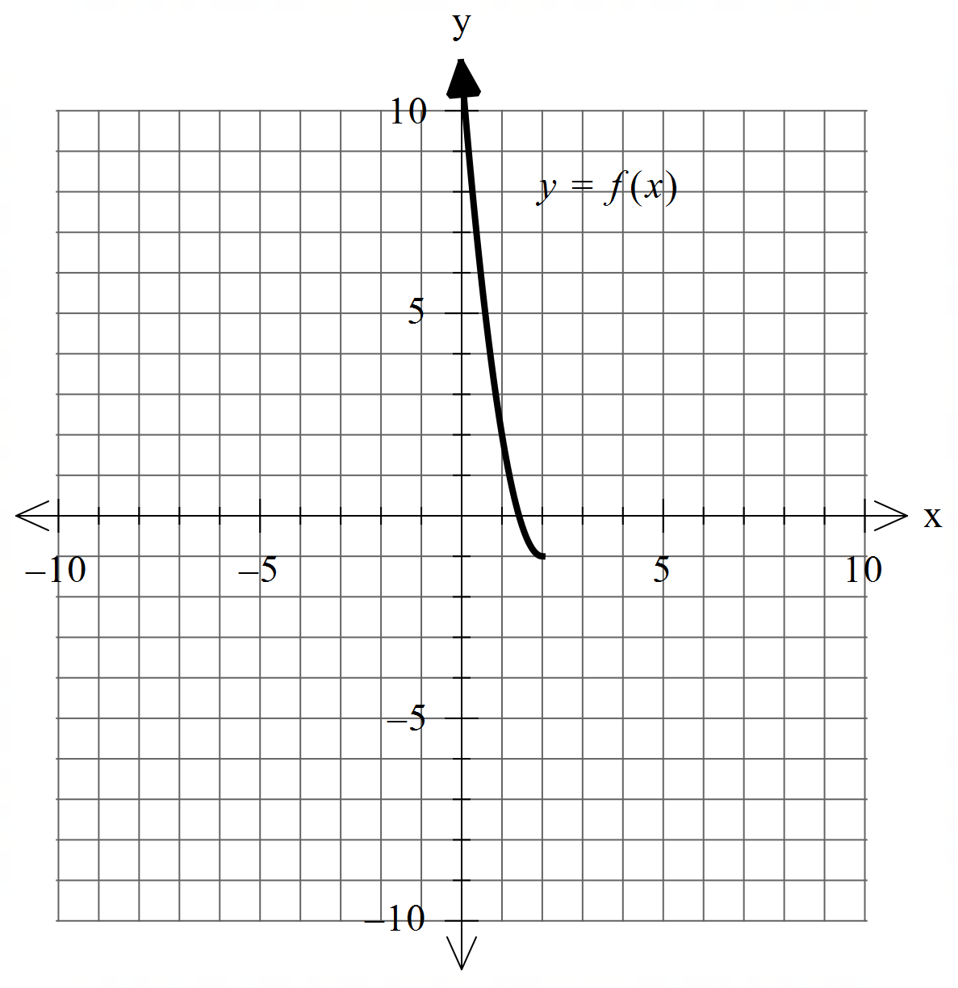

1. Sketch the inverse function  on the axes above. (2 marks)
2. Determine the rule for  and state its domain. (4 marks)

Q7 continued.

c) Determine  (1 mark)

d) Determine the exact coordinates, if any, where  (3 marks)

**Question 8 (4 marks)**

Consider two parallel planes . Plane  is given by  and plane  contains the point .

Show that the distance between the two planes is given by 

Additional working space

Question number: